**Name : Nikhil Rajendra Danapgol**

**PRN : 2019BTECS00036**

**HPC Lab**

**Assignment 5**

**Batch : B2**

Title: **Installation of MPI and implementation of basic functions of MPI**

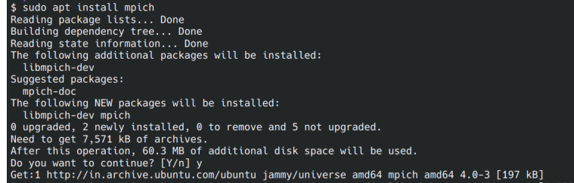

**—-----------------------------------------------------------------------------------------------**

1. **Implement a simple hello world program by setting number of processes equal to**

#include <mpi.h>

#include <stdio.h>

int main( int argc, char *argv[] )

{

MPI_Init( &argc, &argv );

printf("Hello, world!\n");

return 0;

}

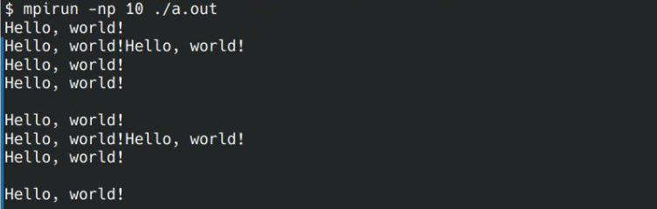

**2. Implement a program to display rank and communicator group of five processes.**

**Code:**

#include <mpi.h>

#include <stdio.h>

int main( int argc, char *argv[] )

{

MPI_Init( &argc, &argv );

int rank;

MPI_Group group;

MPI_Comm_group(MPI_COMM_WORLD, &group);

MPI_Comm_rank(MPI_COMM_WORLD, &rank);

printf("Rank: %d, Group: %d \n", rank, group);

MPI_Finalize();

return 0;

}

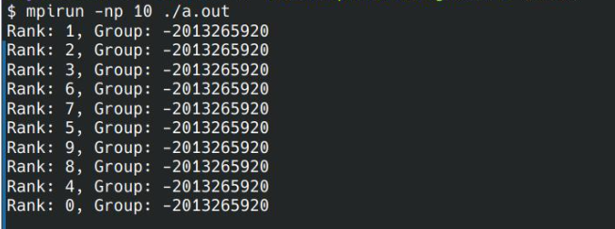

**Github Link:**

[**https://github.com/nd22052000/HPC**](https://github.com/nd22052000/HPC)